STAT3011 Report — Outlier Detection (Group 23)
- Converted categorical variables into numerical variables
- Standardized different numerical variables to bring them to a similar scale and ensure the stability of test results (Since the variables show significant differences in their value ranges: "age" ranges from 17 to 31, "stay" from 1 to 10, "todep" from 0 to 25, "tosc" from 8 to 48, and "toas" from 36 to 145)
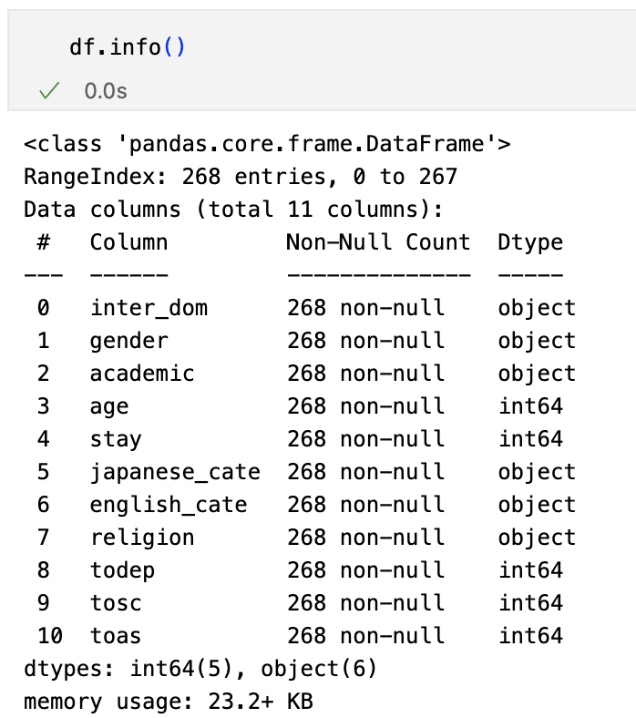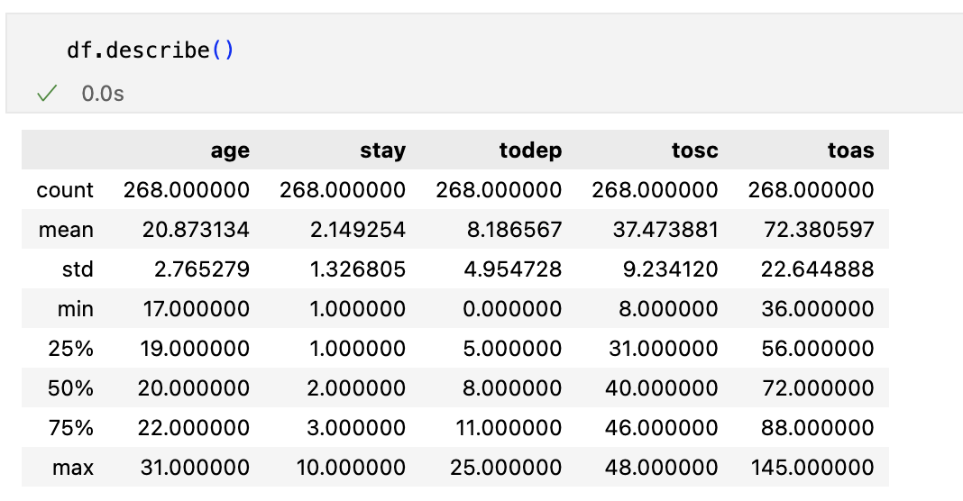
- Chose iForest for its high efficiency and robustness in high-dimensional data. Furthermore, since our dataset contains multiple categorical variables, even after encoding, it still affects the performance of the KNN and LOF models (both of which rely on distance calculations). In contrast, iForest relies on random partitioning to isolate anomalies and is therefore unaffected by the presence of categorical variables, making it more suitable for our dataset.
- Set probability threshold = 0.75 because apart from the medical model which requires a threshold of 0.9, 0.75 meets the requirements of most models
- Set random_state = 10 to enable reproducibility
- Optimized the parameters of iForest (n_estimators, max_samples, contamination)
- Used RMSE to evaluate different choices of parameters and chose the one with the smallest RMSE value. Using this method, we can effectively optimize the model parameters and find the suitable one.
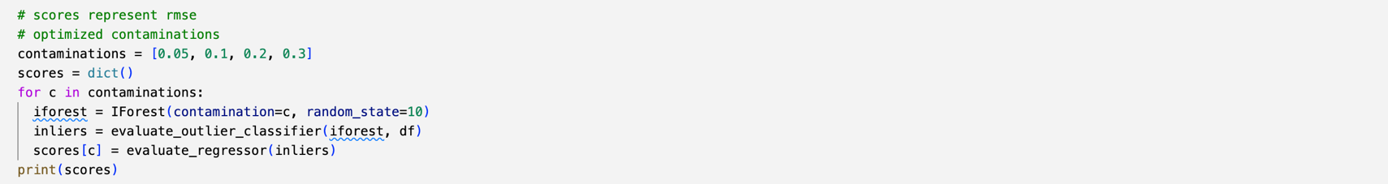
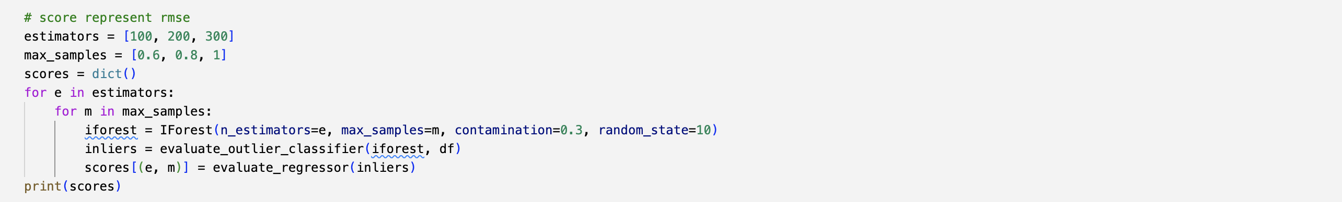
- Fitted IForest model with optimal parameters to find outliers (contamination = 0.3, n_estimators = 200, max_samples = 0.8)
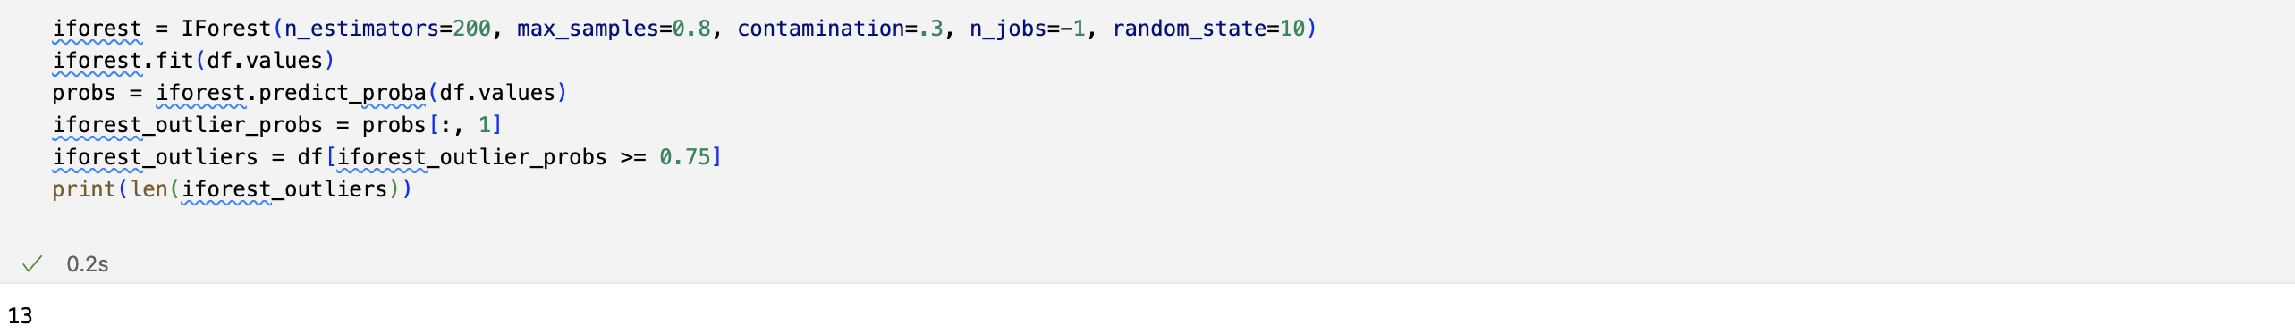
- Successfully found 13 outliers in the dataset and showed the detail of them
- Visualized outliers
